**SOFTWARE REQUIREMENT SPECIFICATION DOCUMENT**

**Project**

# **RFID Asset management System**

**UKB Electronics Noida**

**Customer: UKB Electronics**

**Submitted By:**



Notice

*This document contains information, which is the proprietary property of* **Sato Argox***. This document is receive in confidence and its contents cannot be disclose or copy without the prior written consent of* **Sato Argox***.*

*Nothing in this document constitutes a guaranty, warranty, or license, express or implied.* **Sato Argox** *disclaims all liability for all such guaranties, warranties, and licenses, including but not limited to: Fitness for a particular purpose; merchantability; not infringement of intellectual property or other rights of any third party or of* **Sato Argox***; indemnity; and all others. The reader is advice that third parties can have intellectual property rights that can be relevant to this document and the technologies discussed herein, and is advice to seek the advice of competent legal counsel, without obligation of* **Sato Argox**

**Sato Argox** *retains the right to make changes to this document at any time, without notice.* **Sato Argox** *makes no warranty for the use of this document and assumes no responsibility for any errors that can appear in the document nor does it make a commitment to update the information contained herein.*

**COPYRIGHT**

*Copyright © Sato Argox 2023. All rights reserved.*

**TRADEMARKS**

*\*Other product and corporate names may be trademarks of other companies and are use only for explanation and to the owners' benefit, without intent to infringe.*

# Document Revision History

|  |  |  |  |
| --- | --- | --- | --- |
| Revision Number | Date | Prepared By | Comment |
| 2.00 | Jan. 19, 2023 | Akhilesh Kumar | Original Document |

**Acronym**

**Customer:** UKB Electronics henceforth will be referred as UKB.

**Vendor:** Sato Argox India Pvt. Ltd. henceforth will be referred as SATO.

Contents

Document Revision History 3

PROJECT SCOPE 6

System Requirements 6

Desktop Computers OR Server 6

Introduction 7

PC - Application 8

Login Screen (Desktop App) 8

Password Change Screen (Desktop App) 9

PC - Application Menu 10

Master Menu (Desktop App) 10

Report Menu (Desktop App) 10

Process Menu (Desktop App) 10

Master Management 12

Group Master (Desktop App) 12

User Master (Desktop App) 13

Plant Master (Desktop App) 13

Asset Master (Desktop App) 14

Process Management 17

Dispatch Doc Generation (Desktop App) 14

Asset Approve (Desktop App) 14

Report Management 18

Report (Desktop App) 18

HHT Screens 19

Login Screen (HHT) 19

Setting (HHT) 20

Main Menu (HHT) 21

Asset Dispatch (HHT) 22

Asset Receiving (HHT) 23

Stock Take (HHT) 24-25

# PROJECT SCOPE

The scope of the solution is to equip users with a RFID Asset management System Solution along with Data scheduler Application through which users can dispatch and receive the product for verification based on several logics to avoid duplicity and ok product get dispatch. This would require the development of the HHT Application for scanning of product, Data scheduler Application & PC Application for Managing Master, process and Reports. The document lays down the specifications of the middleware Application, its architecture and infrastructure requirements.

# System Requirements

This section provides the necessary details about the hardware components required by the solution.

## Desktop Computers OR Server

The desktop Application would require the computer with following specifications: -

* Intel Core 8th Gen Intel i5 or better CPU
* Operating system - Microsoft Windows 7 or 10
* 4 GB RAM
* 500 GB Hard disk Or above
* Dot net Framework 4.5 Preinstalled or above
* SQL 2014 or above Express or Std. Edition
* MS Access (pre- installed)
* IIS Pre Installed

# Introduction

The scope of this document is to provide the understanding of this solution to all members of UKB Team & Sato Argox Team associated with the solution development & implementation. This document major emphasize on solution processes & user operations, where the data will be capture and afterwards will be use.

This solution major comprises of followings:

PC Application

* Master Managements
* Process Managements
* Reports

HHT Android Application

* Login
* Connection Settings
* Product Dispatch
* Product Receiving
* Asset Locator

This Document will help the end client to understand the Application and its implementation in various places with the help of screen shots and brief description supporting the images. In addition, these images carries the idea how the Application GUI will look like, the product can have slight visual differences.

## PC - Application

## Login Screen (Desktop App)

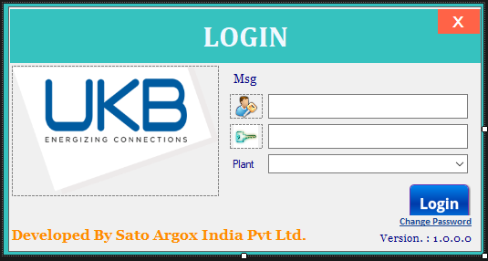

*Action available: Login*

**Brief Description:** This screen will use for login purpose. User will enter User ID & Password; system will validate entered user ID & password. Then according to user rights assigned to user, menus of Main Menu screen will be enable.

**Function Description in Detail:**

|  |  |  |  |
| --- | --- | --- | --- |
| **Sr No.** | **Function** | **Description** | **Remarks** |
| 1. | Login | 🡪User will enter User ID & password and select plant  🡪User will click on Login Button  🡪**Application will validate user id, Password and plant into database. If ok Application will move to main screen.** |  |

## Password Change Screen (Desktop App)

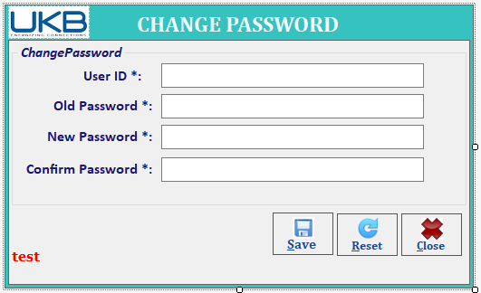

*Action available: Change Password*

**Brief Description:** This screen will use for changing the password purpose. User will enter User ID & current password; system will validate entered user ID & password. User will enter the New Password and Confirm the New password, system will validate the password and user can save the new password.

**Function Description in Detail:**

|  |  |  |  |
| --- | --- | --- | --- |
| **Sr No.** | **Function** | **Description** | **Remarks** |
| 1. | Password Change | 🡪User will enter User ID & password; New Password & Confirm Password.  🡪User will click on Save Button  🡪**Application will validate user id & Password into database. If ok Application will update the New password.** |  |

## PC - Application Menu

### Master Menu (Desktop App)

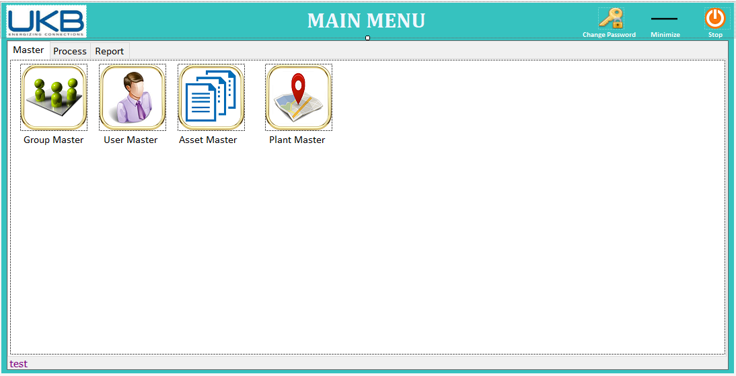

### Process Menu (Desktop App)

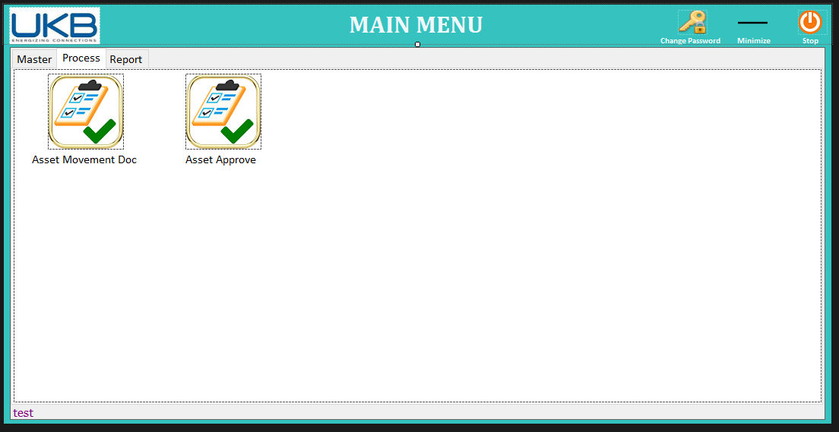

### Report Menu (Desktop App)

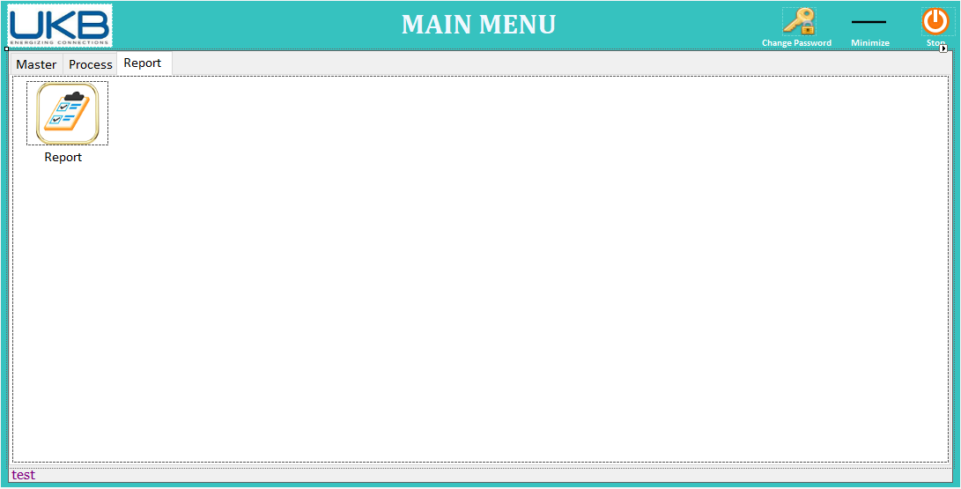

## Master Management

### Group Master (Desktop App)

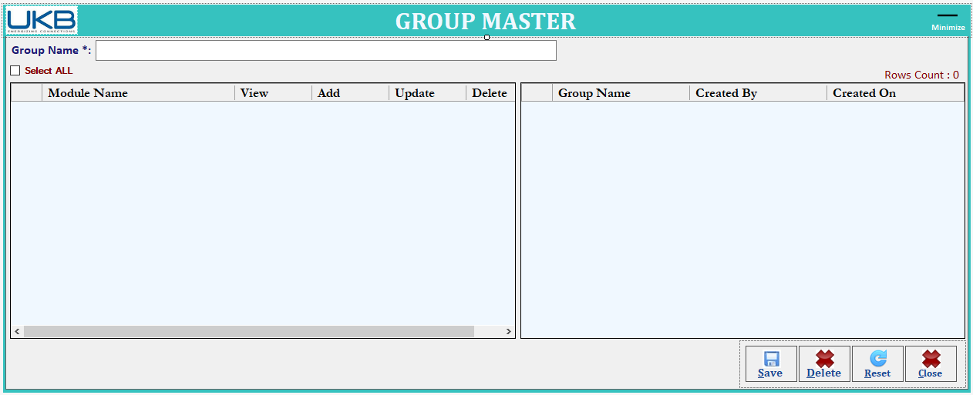

*Action available: Save, Delete, Reset, Close*

**Brief Description:** This User Group Master where user can create multiple Groups like Admin, User etc.

User can provide the rights/access as per their requirement.

**Function Description in Detail:**

|  |  |  |  |
| --- | --- | --- | --- |
| **Sr No.** | **Function** | **Description** | **Remarks** |
| 1. | SAVE | 🡪User will enter new User Group information.  🡪On click of *SAVE* button, system will check for duplicate records and respected messages of success or failure will be display to user.  🡪All fields gets cleared. |  |
| 2. | Delete | 🡪Double Click on the view record and click on delete button. |  |
| 3. | RESET | 🡪Resets the current screen controls. |  |

### 

### User Master (Desktop App)

*Action available: Save, Delete, Reset*

**Brief Description:** This screen will use to manage User Master via Save & Cancel Operation for using the Application.

**Function Description in Detail:**

|  |  |  |  |
| --- | --- | --- | --- |
| **Sr No.** | **Function** | **Description** | **Remarks** |
| 1. | SAVE | 🡪User will enter the user name, user id (for login id), password and select the group.  🡪On Group section, automatically rights will Apply as per the group section.  🡪On click of *SAVE* button, system will check for duplicate records and respected messages of success or failure will be display to user.  🡪All fields gets cleared. |  |
| 2. | Delete | 🡪 Click on saved record on view and click on delete button. |  |
| 3. | RESET | 🡪Resets the current screen controls. |  |

### Plant Master (Desktop App)

*Action available: Save, Delete, Reset*

**Brief Description:** This screen will use to manage the Plant master details like Plant Code and Description.

**Function Description in Detail:**

|  |  |  |  |
| --- | --- | --- | --- |
| **Sr No.** | **Function** | **Description** | **Remarks** |
| 1. | Add | 🡪Users need to enter the Plant Code, Floor, section, and description  🡪On click of *Add* button, application will validate Plant Code, Floor, section and show in grid.  This process will repeat, and data added in grid. |  |
| 2. | SAVE | 🡪On click of *SAVE* button, system will save Plant Code, Floor, section details into the database.  🡪Application checks for duplicate records while uploading/save against plant and Floor, section  🡪All fields get cleared. |  |
| 3. | Delete | 🡪 Double Click on saved record on view and click on delete button. |  |
| 4. | RESET | 🡪Resets the current screen controls. |  |

### Asset Master (Desktop App)

*Action available: Save, Delete, Reset*

**Brief Description:** This screen is use to manage the asset master details like asset code, asset name, RFID Tag etc.

**Function Description in Detail:**

|  |  |  |  |
| --- | --- | --- | --- |
| **Sr No.** | **Function** | **Description** | **Remarks** |
| 1. | SAVE | 🡪User need to enter/select the Asset master details like Plant, Floor, Section, Asset Code, Description, RFID Tag. etc.  🡪On click of *SAVE* button, system will save product master details into the database.  🡪Application checks for duplicate records while uploading/save against Product Code.  🡪All fields gets cleared. |  |
| 2 | Delete | 🡪 Double Click on saved record on view and click on delete button. |  |
| 3. | RESET | 🡪Resets the current screen controls. |  |

## 

## Process Management

### Doc No. Generation for Asset Movement (Desktop App)

*Action available: Add and Save, Reset*

**Brief Description:** This screen will be used to Generation Doc No. for dispatching.

* Application will generate the doc no. no. automatically.
* Doc No. format will be like Doc-ddMMyy-0001
* Eight Digit Date Month Year and last four digit will be auto increment serial no.
* User will select from Plant, To plant, From Floor To Floor, From Section To Section
* ,Asset Code and enter the dispatch Quantity as per need to dispatch.
* On click of *Add* button location, product and quantity will be added in grid
* This process will be repeating as per required product for dispatching.
* User will click on save button to save the selected file data against the doc no.
* Note: Email will be send to Approver after doc generation.

## Note: After saved successfully, Application will show the doc no. User should note down the Doc no. Same doc no will be used for further dispatch for asset dispatching.

## 

### Asset Approve (Desktop App)

*Action available: Approve, Reset*

**Brief Description:** This screen will be used to Approve Assert for dispatch.

* User will select Plant and Doc No. then all details will populate in grid.
* User will validate the details from grid and click on approve button for dispatch the data.

## Report Management

### Report (Desktop App) – Scanning Report

*Action available: Search, Export, Reset*

**Brief Description:**

* **From Date:** User will select form date.
* **To Date:** User will select to date.
* **Optional parameters:**

1. **Select Location**: User will select plant.
2. **Select Product**: User will select Asset.

**Function Description in Detail:**

|  |  |  |  |
| --- | --- | --- | --- |
| **Sr No.** | **Function** | **Description** | **Remarks** |
| 1. | SEARCH | 🡪On click of *SERACH* button, system will get the all details as per the selected parameters. |  |
| 2 | Export | Export the Report data in CSV file. |  |
| 3. | RESET | 🡪Resets the current screen controls. |  |

## HHT Screens

### Login Screen (HHT)

*Action available: Login*

**Brief Description:** This screen will use for login purpose. User will enter User ID & Password; system will validate entered user ID & password. Then according to user rights assigned to user, menus of Main Menu screen will be enabled.

**Function Description in Detail:**

|  |  |  |  |
| --- | --- | --- | --- |
| **Sr No.** | **Function** | **Description** | **Remarks** |
| 1. | Login | 🡪User will enter User ID & password and plant  🡪User will click on Login Button  🡪**Application will validate user id & Password into database. If ok Application will move to main screen.** |  |

### 

### Setting Screen (HHT)

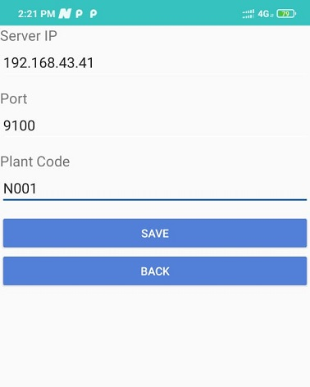

*Action available: Setting*

**Brief Description:** This screen will use for server configuration purpose. User will enter Server ID & Port No and Plant code; system will validate all field.

**Function Description in Detail:**

|  |  |  |  |
| --- | --- | --- | --- |
| **Sr No.** | **Function** | **Description** | **Remarks** |
| 1. | Save | 🡪User will enter server ID & Port No. and Plant Code  🡪User will click on Save Button |  |

### Main Menu (HHT)

**Brief Description:** This screen will be used to select different operations in the HHT.

### Asset Dispatch Scanning (HHT)

**Brief Description:** User will follow the following steps.

This screen will be used to dispatch the asset from plant.

* User will select the doc no. from the drop down then, to plant and asset details will be display...
* User will read the asset tag.
* If the tag barcode is valid then the App will save the details else prompt message will display on the screen with details in case of wrong barcode scanned.
* **Note: Approve Doc will populate in Doc section Drop down.**

### Asset Receiving Scanning (HHT)

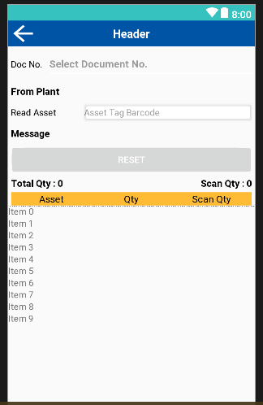

**Brief Description:** User will follow the following steps.

This screen will be used to receive the asset to other plant.

* User will select the doc no. from the drop down then dispatched asset details and dispatched plant will be display.
* User will read the tag barcode.
* If the tag barcode is valid then the App will save the details else prompt message will display on the screen with details in case of wrong barcode scanned.

### Stock Take Scanning (HHT)

**Brief Description:** User will follow the following steps.

This screen will use to identify the asset against RFID Tag and asset Code.

* User will select Plant, Floor, Section then Asset code, Qty details will populate in grid.
* User will click on start Asset then screen will start for stock take
* User will enter/scan RFID tag or asset code.
* User will click on view button if need to check the details.
* After all stock completed user will click on complete button to complete the stock take.

### Stock Take Scanning (HHT)

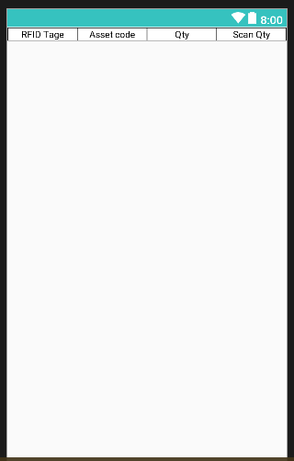

This screen will use to populate the stock take details after click on view button from stock take screen.